Detailed Implementation Document
Weblogic OSB PROD

Author: Relocation Architect Henrik Ridder
Owner: Account Architect Mats Samuelsson
Document Date: 18-04-2016
Customer: Finnair

Finnair DID Weblogic OSB_PROD v0.5
Document History
Document Location
This document is only valid on the day it was printed. Ensure that this document is current. Printed documents and locally copied files will become obsolete due to changes to the master document.
Latest version can be found in the FINNAIR T&T community:
https://apps.na.collabserv.com/communities/service/html/communityview?communityUuid=82981a64-79a1-40e4-9c66-1d33f5c767c9#fullpageWidgetId=Wca99a4629107_480c_9363_e75639b35da8&folder=93d47d28-9659-4517-a310-6a0dce2a003d

Revision History
Revision Number | Revision Date | Summary of Changes / Iteration Level | Changes marked
0.1 | 18 April 2016 | Henrik Ridder Initial version | N
0.2 | 21 April 2016 | Review by Sami Marjokorpi | N
0.3 | 25 April 2016 | Review by Allan Unnerup | N
0.4 | 13 May 2016 | Removed references to Oracle databases in table 5-16 | N
0.5 | 31 May 2016 | Added db connections and LB info | N
Approvals
This document requires approval from the following. Signed approval forms are filed in the FINNAIR T&T community
Name | Title / Organization
Matti Alanne | Architect /Service Manager Finnair
Allan Unnerup | T&T Architect / IBM
Seppo Pöyhönen | Architect / Finnair
Ari Maronen, | Service Manager / Finnair
Distribution
This document has been distributed to the following people / organizations.
Name | Title / Role / Organization
Matti Alanne | Architect / Finnair
Jason Papadopoulos | Project / Finnair
Sanjay Munshi | Enterprise Platforms Tower Lead / Project Manager / IBM
Mats Samuelsson | Chief Architect / Finnair Account Architect / IBM
Allan Unnerup | Architect / T&T Architect / IBM
Taito Halonen | Platform Responsible / IBM
Bent Gregersen | Database Responsible / IBM
Jyrki Seppä | IT Delivery, SSO / IBM
Staffan Wall | Project Manager / IBM
Contents

Contents
Document History 2
Document Location 2
Revision History 2
Approvals 2
Distribution 2
Contents 4
Contents 4
1. Executive Summary 7
2. Preface 8
2.1 Introduction & Background 8
2.2 Purpose of this Document 8
2.3 Input Sources for this Document 8
2.4 Scope 8
2.4.1 Included in Scope 8
2.4.2 Excluded from Scope 8
2.5 Stakeholder Details 8
2.6 Statement of Assumptions 9
2.7 Definitions & Glossary 9
2.8 Copyright 10
3. Current System 11
3.1 Current System Context 11
3.2 Current Application Model and Interfaces 12
3.2.1 Application Details 13
3.2.2 Application Interfaces 13
3.2.3 Users 21
3.2.4 Printing 21
3.3 Current Operational Model 21
3.3.1 Current IT Environment 21
3.3.2 Current Platform/Node Descriptions 22
Admin PC 22
Application servers 24
3.3.3 Current Server Details 24
3.3.4 Current Storage and Database Information 26
3.4 Current Network Model 27
3.4.1 Network Topology 27
3.4.2 Current Network Connections 27
3.5 Current Environments Model 27
3.6 Current Systems Management Model 28
3.6.1 Availability 28
3.6.2 Backup & Recovery Management 28
3.6.3 Operations Management 28
3.6.4 Batch Management 28
3.6.5 Performance / Capacity Management 28
3.6.6 Change Management 28
3.6.7 Configuration / Inventory Management 28
3.6.8 Security Management 28
3.6.9 Disaster Recovery / Continuity Management 29
3.6.10 Problem Management 29
3.6.11 Data Management 29
3.6.12 Software Control & Distribution 29
3.6.13 Service Level Management 29
4. Requirement Analysis 30
4.1 Applicable Documentation 30
4.2 Acceptance 30
4.3 Finnair Responsibilities 30
4.4 Change Cases 30
5. Target Solution 31
5.1 Target Solution Overview 31
5.2 Target System Context 31
5.3 Target Operational Model 31
5.3.1 Architectural Decisions 32
5.3.2 Target Server details 32
5.3.3 Target Storage & Database Information 34
5.4 Target Network Model 35
5.4.1 Target Network Topology 35
5.4.2 Target Network Connections 35
5.5 Target Systems Management Model 41
5.5.1 Availability 41
5.5.2 Backup & Recovery Management 41
5.5.3 Operations Management 42
5.5.4 Batch Management 42
5.5.5 Performance / Capacity Management 42
5.5.6 Change Management 42
5.5.7 Configuration / Inventory Management 42
5.5.8 Security Management 42
5.5.9 Disaster Recovery / Continuity Management 42
5.5.10 Problem Management 42
5.5.11 Data Management 42
5.5.12 Software Control & Distribution 42
5.5.13 Service Level Management 42
5.6 Testing and Validation 43
5.7 System Acceptance 43
5.8 Deployment 43
5.9 Documentation 44
6. Transformation guidelines 45
7. Service Move 46
7.1 Cutover Plan 46
7.1.1 Architectural input 46
7.2 Move Day Timeline 49
7.3 Communication plan 49
7.4 Rollback plan 49
7.5 Risk Assessment 49

Executive Summary
The Weblogic OSB environment is based on Weblogic Server 10.3.0.6 and Oracle Service Bus 11.1.1.7 with multiple applications.
The applications are used by many users.
The Weblogic OSB system is a critical system running at Gold level SLO.
The Weblogic OSB system is available in a production setup (this DID), also a pre-production setup exists, but is not part of this DID. The Weblogic OSB applications are accessed today via applications programs.
OSB application are using Load Balancing setup in both production and Preproduction environment.
This DID does not cover this part, solution for Load Balancing will be determined seperat in workshops with Neos, IBM and FINNAIR.
The Weblogic OSB system will be reinstalled and transformed to a central application running from IBM DC. The Weblogic OSB system will be located locally on the servers.
Data migration will be done via LAN.
Migration and cutover plan will follow general template and approach, and this can be seen in other documents.
Risk letter is necessary for relocated servers, since CGI will be handling servers until end of May.
Process for creating risk letter is ongoing.

Baseline
Current System Information
Server name | Node type | Type/Model | Serial number | No. of CPUs | Memory | Location
MDWPAPA1 | Physical | AIX 5.3 64 bit | N/A | 2 | 16 GB | NEOS DC
MDWPAPA2 | Physical | AIX 5.3 64 bit | N/A | 2 | 16 GB | NEOS DC

Target System Information
Server Name | Node type | Type/Model | Serial Number | No. of CPUs | Memory | Location
AYVAPOSBAP01 | Virtual | AIX 7.1 64 bit | N/A | 2 | 16 GB | IBM DC
AYVAPOSBAP02 | Virtual | AIX 7.1 64 bit | N/A | 2 | 16 GB | IBM DC

Preface

Introduction & Background
The agreed servers at Neos are to be transformed and relocated from the current location in the Neos datacentre to IBM’s dual site computing centre in Suvilahti and Munkkiniemi..

Purpose of this Document
- Provide a vision of the architecture and scope of the proposed IT system
- Enable recognition and validation of the implications of the architectural approach
- Ensure a complete migration of the system and all of it components

Input Sources for this Document
The following sources were used as references in the preparation of this document, but they are specifically not part of the Solution Design Definition.

- MASTER Finnair Servers Baseline 160314.xlsx
- Application_list-2015-08-25T10-42-40.xlsx
- questionnaire for ITOSB PRE_PROD_SP_v2.xlsx
- AYCRM_Firewall_Rules_V_14.xlsx
- Finnair Mobile Architecture_v1.1.docx

Scope

Included in Scope
The following are specifically included in scope:
- The servers listed in the tables in section 3.3.3 Current Server Details as these are the definitive list of servers/devices that will be transformed and relocated. These tables take precedence over any other list in this document.

Excluded from Scope
The following are specifically excluded from the relocation scope:
None identified.

Stakeholder Details
The contact details for all individual stakeholders are listed in the table below.

Table 2-1 Stakeholder Details
Role | Responsibilities | Name | E-mail |  | Mobile phone number
Service Manager (Finnair) | Owner of the application/service | Ari Maronen | ari.maronen@finnair.com |  | +358503931915
Business owner | Support to application | Ari Maronen | ari.maronen@finnair.com |  | +358503931915
Architect | Finnair’s responsible architect | Seppo Pöyhönen | seppo.poyhonen@finnair.com |  | +358405933321
Project Manager | Finnair’s responsible project manager | Jason Papadopoulos | jason.papadopoulos@finnair.com | Weblogic OSB server | ´+358505232533
Application Administrator | Administrator of the application | CGI / IBM | CGI: lassi.jatkola@cgi.com |  | +358503905834
Software vendor (If applicable) | Support / Maintenance | CGI / IBM / Oracle
OSB specialist | Installation and configuration | Bent E Gregersen | bege@dk.ibm.com |  | +45 4120 3864
DID author | DID writer | Henrik Ridder | ridder@dk.ibm.com |  | +45 28808587

Statement of Assumptions
N/A

Definitions & Glossary
Term | Description
SUV | Suvilahti  One of the sites at CDC Finland
MUN | Munkkiniemi.  One of the sites at CDC Finland
CDC | Central Data Centre
DID | Detailed Implementation Document
ISM | IBM Service Management
ODBC | Open Data Base Connectivity
PIT | CGI Location
RDP | Remote Desktop Protocol
RPE2 | Relative Performance Estimate version 2
SAN | Storage Area Network
SCCM | System Centre Configuration Manager
SLA | Service Level Agreement
SMB | Server Message Block  A request-response protocol for sharing files, printers, serial ports, and communications abstractions such as named pipes and mail slots between computers.
SP2 | Service Pack 2
SQL | Structured Query Language
UAT | User Acceptance Test
USB | Universal Serial Bus
VPN | Virtual Personal Network
WAN | Wide Area Networks

Copyright
IBM has copyright and intellectual property rights on the contents of this document.
© Copyright 2016. IBM Corporation. All Rights Reserved.

Current System
This chapter describes the architecture of the current environment.

Current System Context
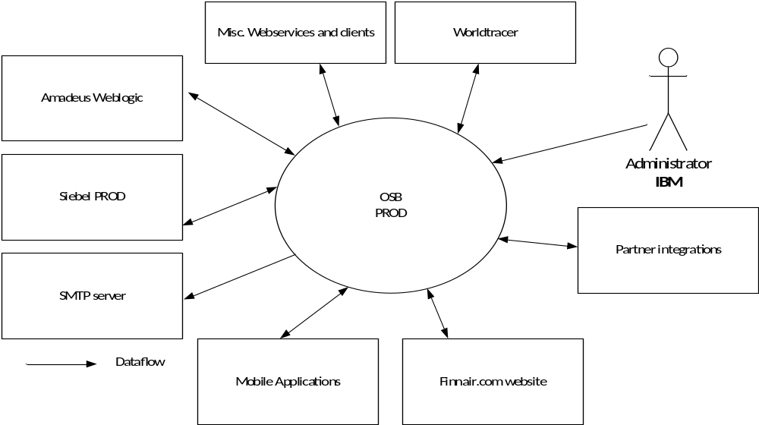

Figure 3-1 System Context Diagram
OSB provides Web Services (SOAP and REST/JSON) for Finnair.com website, Mobile application and partner integrations.
There are around 100 services in internal and external use.
OSB Version: 11.1.1.7
Java version: Aix java6_64
Around 100 OSB business services runs on server, mostly synchronous online services but also some file based integrations.
No configuration database exists, but monitoring report oracle DB. OSB configurations are properly saved on server.
Certificates used is self-signed, but SSL offloading, where used, is done in the HTTP server layer so this should not be of significant importance. Some outgoing https exist, like Google Analytics.

Current Application Model and Interfaces
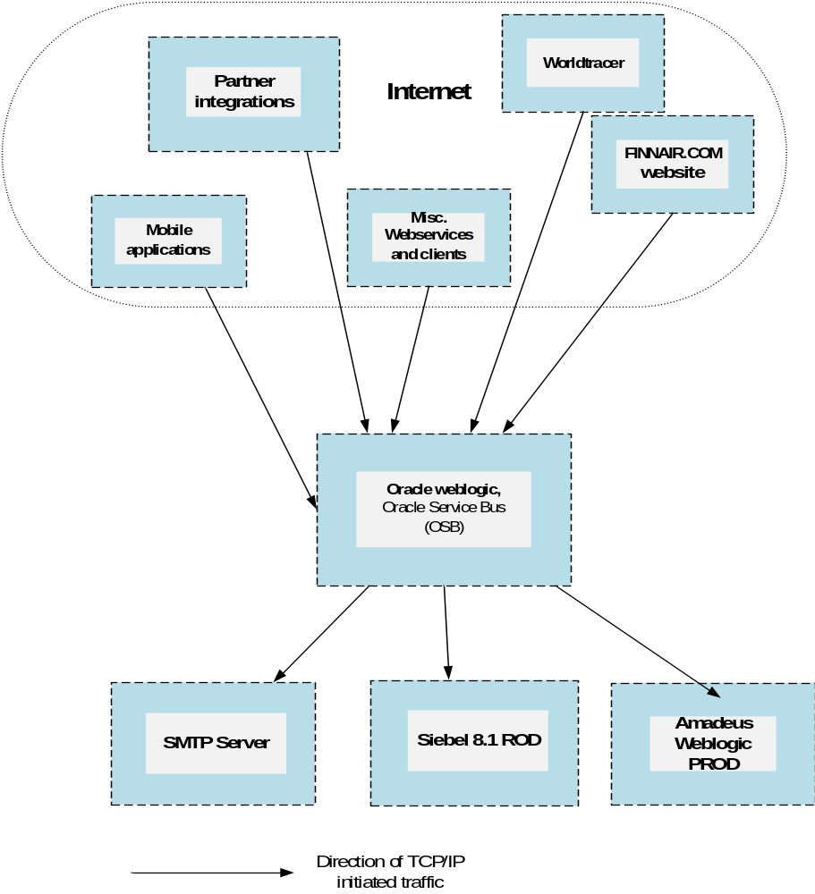
Figure 3-2 Component Model

Application Details
Installation will be done by IBM, Jyrki Seppä and Bent E Gregersen.
IO-code: ITOSB Prod
Criticality: 1
Table 3-2 Current Application List
Application / product name | Version | Vendor | Dist. Package | Comment
Weblogic | 10.3.0.6 | Oracle |  | Manual installation done by IBM, assisted by CGI.
Oracle Service Bus (OSB) | 11.1.1.7 | Oracle |  | Manual installation done by IBM, assisted by CGI.

Application Interfaces
Both DNS lookup and hardcoded IP addresses are used in application
Table 3-3 Application Interfaces
From | To | Data | TCP/IP ports | Comments
172.19.96.202 (MDWPAPA2)  172.19.96.203 (MDWPAPA1) | 157.200.13.44 | PROD MIDDLEWARE SERVER | 25 | SMTP Gateway
172.19.96.202 (MDWPAPA2)  172.19.96.203 (MDWPAPA1) | 172.19.96.234 | PROD MIDDLEWARE SERVER | 80 | Siebel 8.1 PROD Web Server Load balancer IP
172.19.96.202 (MDWPAPA2)  172.19.96.203 (MDWPAPA1) | 194.145.50.111 | PROD MIDDLEWARE SERVER | 80, 443 | www.finnair.fi - production internet front-end
172.19.96.202 (MDWPAPA2)  172.19.96.203 (MDWPAPA1) | 157.200.16.170 | PROD MIDDLEWARE SERVER | 7080 | ADN / Missing points through WBI
172.19.96.202 (MDWPAPA2)  172.19.96.203 (MDWPAPA1) | 57.255.16.128 | PROD MIDDLEWARE SERVER | 443 | WTR
172.19.96.202 (MDWPAPA2)  172.19.96.203 (MDWPAPA1) | 172.19.96.78 | PROD MIDDLEWARE SERVER | 22 | Windows server
172.19.96.202 (MDWPAPA2)  172.19.96.203 (MDWPAPA1) | 172.19.96.79 | PROD MIDDLEWARE SERVER | 22 | Windows server
172.19.96.202 (MDWPAPA2)  172.19.96.203 (MDWPAPA1) | 157.200.88.133 | Siebel 7.8 Environment | 80 | Siebel 7.8 Environment
172.19.96.202 (MDWPAPA2)  172.19.96.203 (MDWPAPA1) | 172.19.96.234 | Siebel 7.8 Environment | 80 | Siebel 8.1 Environment
172.19.96.202 (MDWPAPA2)  172.19.96.203 (MDWPAPA1) | 194.76.166.67 | Middle ware server | 80 | production.webservices.1a.amadeus.net
172.19.96.202 (MDWPAPA2)  172.19.96.203 (MDWPAPA1) | 74.125.39.101, 74.125.39.102, 74.125.39.113, 74.125.39.138, 74.125.39.139, 74.125.39.100 | Middle ware server | 80 | Google Analytics
172.19.96.202 (MDWPAPA2)  172.19.96.203 (MDWPAPA1) | 82.150.229.134 | Middle ware server | 443 | webservices.amadeus.com
172.19.96.202 (MDWPAPA2)  172.19.96.203 (MDWPAPA1) | 172.19.98.10 | Middle ware server | 80
172.19.96.202 (MDWPAPA2)  172.19.96.203 (MDWPAPA1) | 57.255.16.196 | Prod Middleware Server | 443 | WTR
172.19.96.202 (MDWPAPA2) 172.19.96.203 (MDWPAPA1) | 209.85.146.100, 209.85.146.101, 209.85.146.102, 209.85.146.113, 209.85.146.138, 209.85.146.139 | Production MiddleWare Server | 80 | www.google-analytics.com
172.19.96.202 (MDWPAPA2), 172.19.96.203 (MDWPAPA1) | 194.76.166.67 | Production MiddleWare Server | 80, 443 | production.webservices.1a.amadeus.net
172.19.96.202 (MDWPAPA2)/172.19.96.203 (MDWPAPA1) | 172.19.100.164 | Production MiddleWare Server | 3128 | Proxy Server
172.19.96.202 (MDWPAPA2)  172.19.96.203 (MDWPAPA1) | 157.200.16.144 | PROD MIDDLEWARE SERVER | 1525 | BPM Oracle PROD Database
172.19.96.202 (MDWPAPA2)  172.19.96.203 (MDWPAPA1) | prod-ads.webservices.ay.amadeus.net:22006  194.76.166.93 | PROD MIDDLEWARE SERVER | 22006,80 | Altea Data Nexus PROD Environment
172.19.96.202 (MDWPAPA2)  172.19.96.203 (MDWPAPA1) | production.webservices.1a.amadeus.net  194.76.166.67 | PROD MIDDLEWARE SERVER | 80 | Amadeus PROD Environment
172.19.96.202 (MDWPAPA2)  172.19.96.203 (MDWPAPA1) | gw1.roottori.fi/eapi/push  87.108.54.100 | PROD MIDDLEWARE SERVER | 80, 443 | SMS Gateway Provider - Roottori
172.19.96.202 (MDWPAPA2)  172.19.96.203 (MDWPAPA1) | es20.bookit.net  193.185.151.59 | PROD MIDDLEWARE SERVER | 8080, 443 | SMS Gateway Provider - BookIT
172.19.96.202 (MDWPAPA2)  172.19.96.203 (MDWPAPA1) | 172.19.96.234 | PROD MIDDLEWARE SERVER | 80 | Siebel Loyalty PROD Environment
172.19.96.202 (MDWPAPA2)  172.19.96.203 (MDWPAPA1) | 194.145.50.90 | PROD MIDDLEWARE SERVER | 8080, 8070,  9090, 9080 | BPM PROD Environment
172.19.96.202 (MDWPAPA2)  172.19.96.203 (MDWPAPA1) | was-applications.finnair.fi  157.200.15.200 | PROD MIDDLEWARE SERVER | 80 | Scope PROD Environment
172.19.96.202 (MDWPAPA2)  172.19.96.203 (MDWPAPA1) | 157.200.16.188 | PROD MIDDLEWARE SERVER | 50000 | Data warehouse DB2 Database
172.19.96.202 (MDWPAPA2) 172.19.96.203 (MDWPAPA1) | 62.61.85.34 | Production Middleware Servers | 80, 443 | SMS Gateway Provider - Roottori
172.19.96.202 (MDWPAPA2) 172.19.96.203 (MDWPAPA1) | 157.200.18.18 | PROD MIDDLEWARE SERVER | 8080,  8070,  9090,  9080 | BPM PROD Environment
172.19.96.202 (MDWPAPA2)  172.19.96.203 (MDWPAPA1) | 157.200.88.134 | PROD MIDDLEWARE SERVER | 80, 443
172.19.96.202 (MDWPAPA2), 172.19.96.203 (MDWPAPA1) | 157.200.75.35 | Middleware Servers | 80 | Scope Production Server
172.19.96.202 (MDWPAPA2), 172.19.96.203 (MDWPAPA1) 172.19.96.204, 172.19.96.205 | 172.19.96.235 | Middleware Servers | 80, 443 | Middleware loadbalancer
172.19.96.202 (MDWPAPA2), 172.19.96.203 (MDWPAPA1) | 172.19.96.74 | Middleware servers | 1415 | Middleware load balancer
172.19.96.202 (MDWPAPA2), 172.19.96.203 (MDWPAPA1), 172.19.96.204, 172.19.96.205 | 172.19.96.10 | Production Application Servers | 80, 9704 | Production Siebel Web Server
172.19.96.202 (MDWPAPA2), 172.19.96.203 (MDWPAPA1) | 157.200.75.41 | PROD MIDDLEWARE SERVER | 389 | Finnair AD
172.19.96.202 (MDWPAPA2)  172.19.96.203 (MDWPAPA1) | nodeA1.production.webservices.1a.amadeus.com/ 171.17.16.33 | PROD MIDDLEWARE SERVER | 80/443 | Amadeus PROD Web service
172.19.96.202 (MDWPAPA2)  172.19.96.203 (MDWPAPA1) | nodeA1.production.webservices.1a.amadeus.com/ 171.17.16.33 | PROD MIDDLEWARE SERVER | 80/443 | Amadeus PROD Web service
172.19.96.202 (MDWPAPA2)  172.19.96.203 (MDWPAPA1) | 157.200.93.25 | PROD MIDDLEWARE SERVER | 25 | SMTP Server
172.19.96.202 (MDWPAPA2)  172.19.96.203 (MDWPAPA1) | www.oneworld.com (66.96.130.69) | PROD MIDDLEWARE SERVER | 80/443 | Amadeus PROD Web service
172.19.96.202 (MDWPAPA2)  172.19.96.203 (MDWPAPA1) | www.web-mn.com (23.23.175.3, 107.20.199.207) | PROD MIDDLEWARE SERVER | 80/443 | Amadeus PROD Web service
172.19.96.202 (MDWPAPA2)  172.19.96.203 (MDWPAPA1) | go.urbanairship.com (184.31.89.14 ) | PROD MIDDLEWARE SERVER | 80/443 | Amadeus PROD Web service
172.19.96.202 (MDWPAPA2)  172.19.96.203 (MDWPAPA1) | 10.100.132.210 | PROD MIDDLEWARE SERVER | 1521 | BPM Oracle PROD Database
172.19.96.202 (MDWPAPA2),172.19.96.203 (MDWPAPA1) | 217.140.134.8 | PROD MIDDLEWARE SERVER | 80 | SMS gateway
172.19.96.202 (MDWPAPA2),172.19.96.203 (MDWPAPA1) | sns.eu-west-1.amazonaws.com( 176.32.110.38)dynamic IP address | PROD MIDDLEWARE SERVER | 443 | Amadeus PROD Web service
172.19.96.202 (MDWPAPA2),172.19.96.203 (MDWPAPA1) | 10.100.160.30 10.100.160.31 10.100.160.40 10.100.160.41 10.100.160.42 | PROD MIDDLEWARE SERVER | 1521 | AYDWH MOB OPS DB
172.19.96.202 (MDWPAPA2),172.19.96.203 (MDWPAPA1) | Web service.worldtracer.aero (57.250.192.197) | PROD MIDDLEWARE SERVER | 443 | World Tracer Service
172.19.96.202 (MDWPAPA2),172.19.96.203 (MDWPAPA1) | 82.150.229.130 | PROD MIDDLEWARE SERVER | 443 | Amadeus PROD Web service
172.19.96.202 (MDWPAPA2), 172.19.96.203 (MDWPAPA1) | 157.200.32.40 | PROD MIDDLEWARE SERVER | 7300
172.19.96.202 (MDWPAPA2), 172.19.96.203 (MDWPAPA1) | 157.200.32.40 | PROD MIDDLEWARE SERVER | 7301
172.19.96.202 (MDWPAPA2), 172.19.96.203 (MDWPAPA1) | 23.57.105.127 | PROD MIDDLEWARE SERVER | 80/443 | www.finnair.com
172.19.96.202 (MDWPAPA2),172.19.96.203 (MDWPAPA1) | 157.200.40.0/22 | PROD MIDDLEWARE SERVER | 80/443
172.19.96.202 (MDWPAPA2),172.19.96.203 (MDWPAPA1) | 157.200.40.0/22 | PROD MIDDLEWARE SERVER | 6379
172.19.96.202 (MDWPAPA2),172.19.96.203 (MDWPAPA1) | 157.200.75.27 | PROD MIDDLEWARE SERVER | 389
172.19.96.202 (MDWPAPA2),172.19.96.203 (MDWPAPA1) | Auth.exacttargetapis.com |  | 80/443
172.19.96.202 (MDWPAPA2),172.19.96.203 (MDWPAPA1) | Auth-test.exacttargetapis.com |  | 80/443
172.19.96.202 (MDWPAPA2),172.19.96.203 (MDWPAPA1) | www.exacttargetapis.com |  | 80/443
172.19.96.202 (MDWPAPA2),172.19.96.203 (MDWPAPA1) | 85.222.128.0/19 | PROD MIDDLEWARE SERVER | 80/443 | SFDCRIPE1
172.19.96.202 (MDWPAPA2),172.19.96.203 (MDWPAPA1) | 85.222.128.0/19 | PROD MIDDLEWARE SERVER | 1024–66535 | SFDCRIPE1
172.19.96.202 (MDWPAPA2),172.19.96.203 (MDWPAPA1) | 185.79.140.0/22 | PROD MIDDLEWARE SERVER | 80/443 | SFDCRIPE2
172.19.96.202 (MDWPAPA2),172.19.96.203 (MDWPAPA1) | 185.79.140.0/22 | PROD MIDDLEWARE SERVER | 1024–66535 | SFDCRIPE2
172.19.96.202 (MDWPAPA2),172.19.96.203 (MDWPAPA1) | 202.129.242.0/23 | PROD MIDDLEWARE SERVER | 80/443 | SFDCAPNIC1
172.19.96.202 (MDWPAPA2),172.19.96.203 (MDWPAPA1) | 202.129.242.0/23 | PROD MIDDLEWARE SERVER | 1024–66535 | SFDCAPNIC1
172.19.96.202 (MDWPAPA2),172.19.96.203 (MDWPAPA1) | 182.50.76.0/22 | PROD MIDDLEWARE SERVER | 80/443 | SFDCAPNIC2
172.19.96.202 (MDWPAPA2),172.19.96.203 (MDWPAPA1) | 182.50.76.0/22 | PROD MIDDLEWARE SERVER | 1024–66535 | SFDCAPNIC2
172.19.96.202 (MDWPAPA2),172.19.96.203 (MDWPAPA1) | 85.222.128.0/19 | PROD MIDDLEWARE SERVER | 80/443 | SFDCRIPE1
172.19.96.202 (MDWPAPA2),172.19.96.203 (MDWPAPA1) | 185.79.140.0/22 | PROD MIDDLEWARE SERVER | 80/443 | SFDCRIPE2
172.19.96.202 (MDWPAPA2),172.19.96.203 (MDWPAPA1) | 96.43.144.0/20 | PROD MIDDLEWARE SERVER | 80/443 | SFDCARIN1
172.19.96.202 (MDWPAPA2),172.19.96.203 (MDWPAPA1) | 136.146.0.0/15 | PROD MIDDLEWARE SERVER | 80/443 | SFDCARIN2
172.19.96.202 (MDWPAPA2),172.19.96.203 (MDWPAPA1) | 204.14.232.0/21 | PROD MIDDLEWARE SERVER | 80/443 | SPDCARIN3
192.168.96.0/24 | 172.19.96.202 (MDWPAPA2)  172.19.96.203 (MDWPAPA1) | ITC Infotech Network | 22,7005, 7070, 7080, 8005, 8070, 8080, 7043, 7053, 8043, 8053 | Middleware PROD Server
157.200.0.0/16 | 172.19.96.202 (MDWPAPA2)  172.19.96.203 (MDWPAPA1) | Finnair Internal Network | 80, 443, 22 | Middleware PROD Server
194.197.255.0/24, 157.200.154.133/32 | 172.19.96.202 (MDWPAPA2)  172.19.96.203 (MDWPAPA1) | Finnair Consultant Network | 80, 443, 22, 7005, 7070, 7080, 8005, 8070, 8080, 7043, 7053, 8043, 8053 | Middleware PROD Server
172.19.96.82 | 172.19.96.202 (MDWPAPA2) | Siebel 8.1 PROD App Server | 80 | Pre-prod Middleware Server
10.100.132.132 | 172.19.96.202 (MDWPAPA2) | PROD INFORMATICA SERVER | 7005 | Middleware PROD
10.100.132.132 | 172.19.96.203 (MDWPAPA1) | PROD INFORMATICA SERVER | 8005 | Middleware PROD
157.200.8.56  157.200.8.57 | 10.100.132.197 | Oracle | 1521 | - AMASESSIONDB
157.200.8.56  157.200.8.57 | munaydwhpdbr05.finnair.fi | Oracle | 1521 | - BPM
157.200.8.56  157.200.8.57 | SCAN-MDPRAC.FINNAIR.FI | Oracle | 1521 | - BPM_Mobile  - wlsbjmsrpDataSource
157.200.8.56  157.200.8.57 | SCAN-DWPRAC.finnair.fi | Oracle | 1521 | - BPM_SDWD
157.200.8.56  157.200.8.57 | 10.100.132.198 | Oracle | 1521 | - SDWODS

Users
The numbers of users are shown in the following table.

Table 3-4 Users
User Categories | Locations (network point of view) | Description | Number of users
Admin users | NEOS datacenter | Ad hoc | 10
Users | Internet | Ad hoc | >100

Printing
No printing from application

Current Operational Model
The operational architecture overview is set out in terms of a high-level model of the primary platform nodes in the system. A platform node is a summarized view of the applications, data, and infrastructure components that make up a single physical or logical node in the infrastructure. Note that the network nodes and connections are defined in the network architecture. This overview also sets out a high level view of the services that will be provided to support the platforms.

Current IT Environment
The platform topology is shown below. This shows the main platform nodes and their connections.
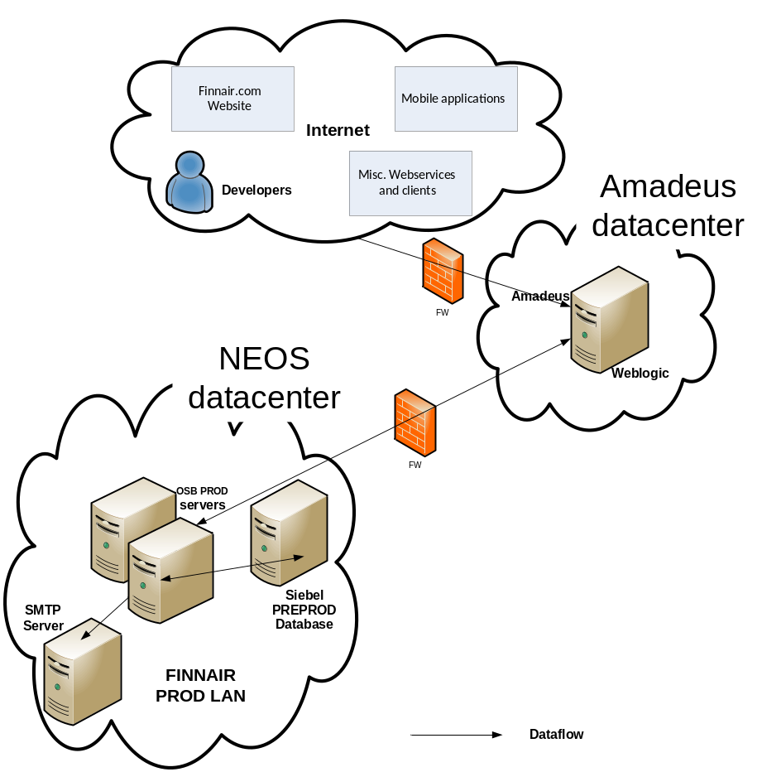

Figure 3-3 Current Operational Model
The above diagram shows the main platform nodes and their connections in the production environment. Actual server names and main application/purpose are placed on the diagram. The connections are at the specification level. The diagram does NOT SHOW ALL physical connections through hubs, wiring closets, and switches.
Component | Resides on | Notes
End users | Internet | Mobile and misc. application interfaces.
SMTP server | Finnair PROD LAN | For sending mails
Amadeus Weblogic | Finnair PROD LAN | Weblogic Web service
Siebel PROD | Finnair PROD LAN | Siebel Web service and database

Current Platform/Node Descriptions

Admin PC
Platform Node | Client PC
Description & Responsibility | User interface
Contents (Files & Databases) | N/A
Contents (System Components & Applications) | Standard Finnair desktop / laptop
Products (Hardware, Operating Systems & Middleware) | Windows workstation  Admin console, telnet  There's an admin console accessed through a browser to access OSB configuration and an SSH connection to the server to manage more technical aspects of the OSB, weblogic and OS in general.
Connectivity & Protocols | Outgoing connections: (from PC to OSB server)  - 22/TCP (Telnet)  - 443/TCP (HTTPS)
Application servers
Platform Node | MDWPAPA1
Description & Responsibility | Weblogic OSB server prod
Contents (Files & Databases) | Weblogic OSB software
Contents (System Components & Applications) | WebLogic Server Version: 10.3.6.0,Oracle Service Bus Version: 11.1.1.7
Products (Hardware, Operating Systems & Middleware) | AIX 5.3 - 64 Bit  WebLogic Server Version: 10.3.6.0,  Oracle Service Bus Version: 11.1.1.7
Connectivity & Protocols | Incomming connections  See Table 3-5 (3.2.2 Application Interfaces)  Outgoing connections  See Table 3-6 (3.2.2 Application Interfaces)

Platform Node | MDWPAPA2
Description & Responsibility | Weblogic OSB server prod
Contents (Files & Databases) | Weblogic OSB software
Contents (System Components & Applications) | WebLogic Server Version: 10.3.6.0,Oracle Service Bus Version: 11.1.1.7
Products (Hardware, Operating Systems & Middleware) | AIX 5.3 - 64 Bit  WebLogic Server Version: 10.3.6.0,  Oracle Service Bus Version: 11.1.1.7
Connectivity & Protocols | Incomming connections  See Table 3-7 (3.2.2 Application Interfaces)  Outgoing connections  See Table 3-8 (3.2.2 Application Interfaces)

Current Server Details
Server function
Table 3-9 Server List (by Usage)
Server name | Node type | Env. | Primary Function | CPU  load | Main Application | Location
MDWPAPA1 | Phys. | Dev | Weblogic OSB server | N/A | Oracle weblogic,  Oracle Service Bus (OSB) | NEOS DC
MDWPAPA2 | Phys. | Dev | Weblogic OSB server | N/A | Oracle weblogic,  Oracle Service Bus (OSB) | NEOS DC

Server Specification
Table 3-10 Server List (by Specification)

Server name | Vendor Type/Model | Serial number | IP address | No. of CPUs | CPU Speed | Memory
MDWPAPA1 | AIX 5.3 – 64 bit | N/A | 172.19.96.203 | 2 | 3000 Mhz | 16 GB
MDWPAPA2 | AIX 5.3 – 64 bit | N/A | 172.19.96.202 | 2 | 3000 Mhz | 16 GB

Current Storage and Database Information

Storage – SAN or local storage
Table 3-11 Current Storage Layout
Server Name | Server Function | Disk Type | No. of HBAs | Total
MDWPAPA1 | Weblogic OSB server | Local attached HD | N/A | 180 GB
MDWPAPA2 | Weblogic OSB server | Local attached HD | N/A | 180 GB

Current Network Model

Network Topology
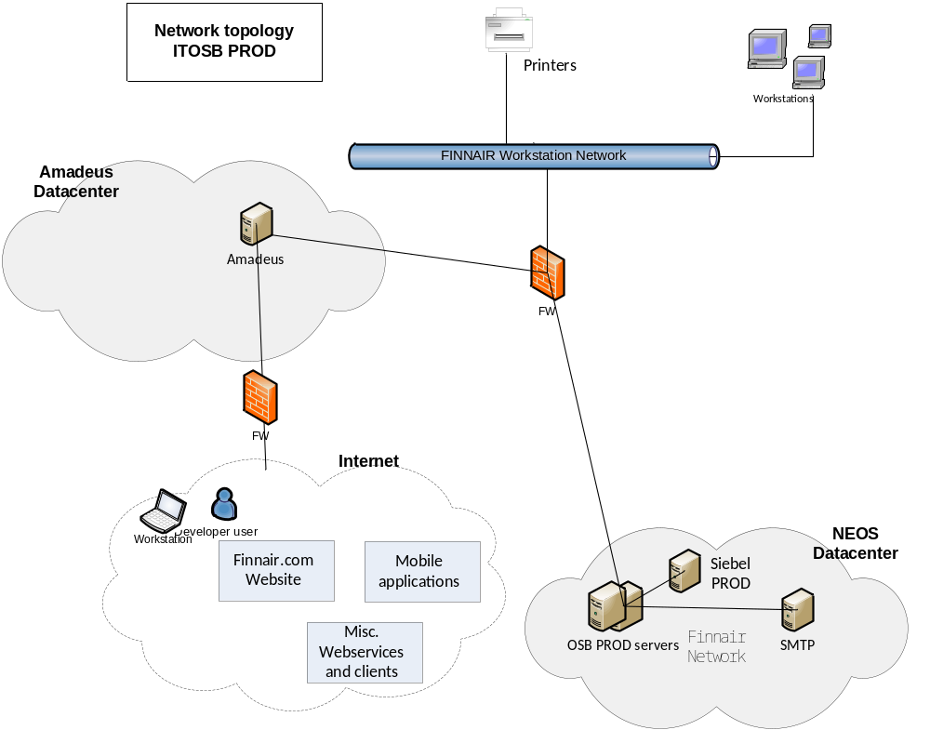

Current Network Connections
Se Table 3-12 Application Interfaces

Current Environments Model
The numbers and platform types of servers supporting each environment are summarized in the following table:
Table 3-13 Current Environments
Environment /  Component | Test | Copy | Prod | Total
MDWPAPA1 | 0 | 0 | 1 | 1
MDWPAPA2 | 0 | 0 | 1 | 1
Total | 0 | 0 | 2 | 2

Current Systems Management Model

Availability
The system is available for 24/7. No scheduled service windows.

Backup & Recovery Management
Table 3-14 TSM Backup List
Hostname | TSM Node Name | TSM Ver-sion | TSM Component Used (b-a, TDP for xxx) | GB Stored on TSM Server | Avg. GB of Daily Backup | TSM Schedules Used | TSM Client Option Set Used
MDWPAPA1 | N/A | N/A | N/A | N/A | N/A | FULL weekly  Incremental daily | N/A
MDWPAPA2 | N/A | N/A | N/A | N/A | N/A | FULL weekly  Incremental daily | N/A

Operations Management
Standard server monitoring is used (Relic agent), on disk, CPU, memory, I/O etc.

Batch Management
Only internal scheduled batch jobs, Currently logs are shipped to an external log storage (Logstash).

Performance / Capacity Management
Currently no performance / capacity tool is used beside standard server tools on ad-hoc basis.

Change Management
All changes to the environment beyond normal server maintenance activities are approved by the Service Manager.

Configuration / Inventory Management
N/A

Security Management
Standard Security Management process is used.

Disaster Recovery / Continuity Management
Restoring of servers and data are done by restoring from backups.

Problem Management
N/A

Data Management
N/A

Software Control & Distribution
Finnair is responsible for purchasing and managing all licenses and certificates.
Software is distributed / installed manually.

Service Level Management
N/A

Requirement Analysis
This section provides an analysis of the solution requirements. The key factors in the requirements are summarized and their implications are stated.
The requirements relative priority can be assigned using the MoSCoW rules of: Must Have = ‘M’, Should Have = ‘S’, Could Have = ‘C’ and Would Like To Have Later, But Will Not Include Now = ‘W’
In this document, the words and phrases that are used to define the significance of each particular requirement are capitalized. These words are:
Must Have This phrase, or the terms "REQUIRED" or "SHALL", mean that the definition is an absolute requirement of the specification.
Should Have While not critical to the success of the project delivery, "SHOULD" items are nearly as important and should be included if it is at all possible. "SHOULD" items are often as important as MUST items, however "SHOULD" items have workarounds allowing another way of satisfying the requirement.
Could Have "COULD" items are less critical and often seen as "nice to have". A few easily built Coulds in a delivery can increase customer satisfaction for little development cost.
Would Like To Have Later, But Will Not Include Now ("WON'T")
This phrase are either the least-critical or lowest-payback items. "WON'T" items are either dropped or reconsidered for reprioritization in later project increments. This, however doesn't make them any less important. Sometimes this is described simply as "Would like to have" in the future. This however leaves some ambiguity in the minds of the users as to its priority compared to the other marks.
Please use these terms consistently throughout the DID. Stick with MUST unless you have a very good reason to write SHALL, as “shall” has different meanings in English and American.

Applicable Documentation
All documentation MUST be written in English.

Acceptance
Technical IT tests (including Service Activation & Deactivation), application tests (Finnair defined) and user acceptance testing (Finnair defined) MUST be met.

Finnair Responsibilities
Finnair is responsible for:
- Installation instructions (should be provided by CGI).
- Creating and performing application tests.
- Creating and performing a user acceptance test.
- Decommissioning of old systems.
All instruction and documentation will be available in English

Change Cases
None.

Target Solution

Target Solution Overview
The new ITOSB PROD system will be built in the IBM dual site data centre Suvilahti and Munkkiniemi in Finland.
The system will be moved to a Virtual server by reinstalling OS and applications in IBM DC.

Target System Context

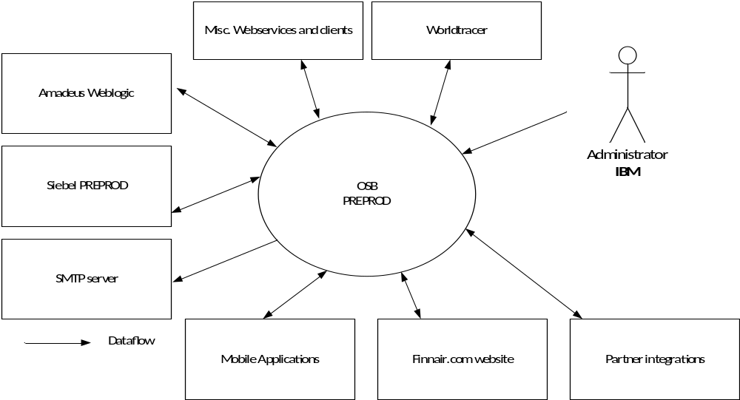
No changes compared to the system context diagram used in section 3.1, except Administrator connection will be IBM managed.

Target Operational Model

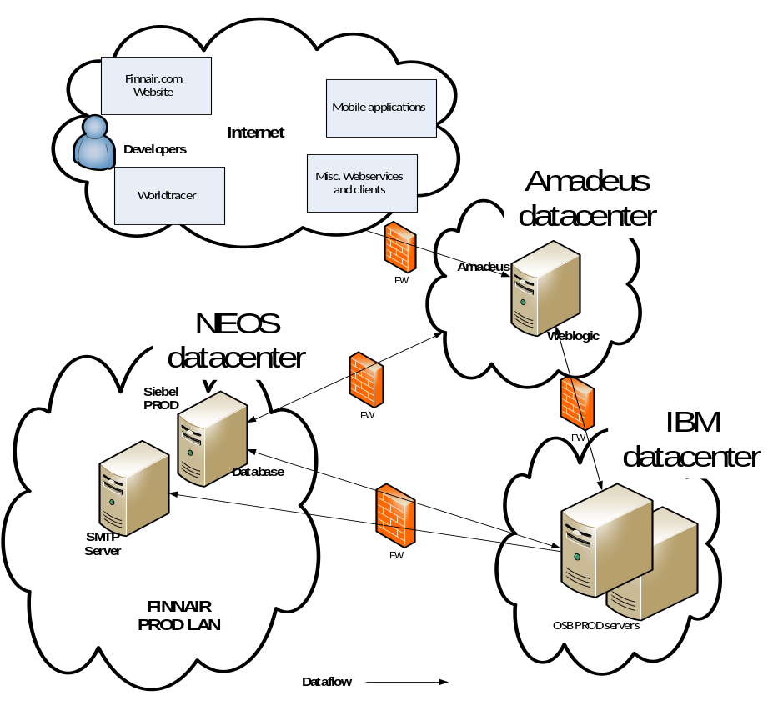

Figure 5-4 Target Operational Model

Architectural Decisions
It has been agreed with FINNAIR to reinstall servers with new version of OS.
Existing AIX 5.3 64 bit
Target AIX 7.1 64 bit
Risk letter is necessary for relocated servers, since CGI will be handling servers until end of May.
Process for creating risk letter is ongoing.

Target Server details
Table 5-15 Target Server Details
New Server Name | Platform Type | Parent Platform | Environment | Network Zone | Location
AYVAPOSBAP01 | Virtual | AIX 7.1 64 bit | Production | Prod Data- VLAN 1139 | IBM DC
AYVAPOSBAP02 | Virtual | AIX 7.1 64 bit | Production | Prod Data- VLAN 1139 | IBM DC

Application servers
Platform Node | AYVAPOSBAP01, AYVAPOSBAP02
Description & Responsibility | Weblogic OSB server prod
Contents (Files & Databases) | Weblogic OSB software
Contents (System Components & Applications) | WebLogic Server Version: 10.3.6.0,Oracle Service Bus Version: 11.1.1.7
Products (Hardware, Operating Systems & Middleware) | AIX 7.1 64 bit  WebLogic Server Version: 10.3.6.0,  Oracle Service Bus Version: 11.1.1.7
Connectivity & Protocols | Incoming connections  See Table 5-20 (Target network connections)  Outgoing connections  See Table 5-20 (Target network connections)

Server Summary
This reallocation is an AS-IS reallocation so the system context and the one function one server approach is not changed from the current system context.
Server function

Table 5-16 Target Server Function
Server Name | Server Function | Env. | OS | Location
AYVAPOSBAP01 | OSB PROD | Production | AIX 7.1 64 bit | IBM DC
AYVAPOSBAP02 | OSB PROD | Production | AIX 7.1 64 bit | IBM DC
Server Specification
Table 5-17 Target Server Specifications
Server Name | Type/Model | Serial Number | No. of CPUs | CPU Speed | Memory | IP Address  Host Name
AYVAPOSBAP01 | OSB PROD | Production | AIX 7.1 64 bit | IBM DC | 16 GB | 157.200.8.56
AYVAPOSBAP02 | OSB PROD | Production | AIX 7.1 64 bit | IBM DC | 16 GB | 157.200.8.57
The Time Zone of the server is set to Eastern Europe Time (Central European Time + 1 hour).
Regional Settings: English
(except for "Language for non-Unicode programs" which is set to English)
Software Components
Table 5-18 Target Application/Software List
Nr. | Server Name | Software Component | Version | Vendor | Method | Comment
1 | AYVAPOSBAP01, AYVAPOSBAP02 | Weblogic | 10.3.0.6 | Oracle | Re-installation | IBM will install
2 | AYVAPOSBAP01, AYVAPOSBAP02 | Oracle Service Bus (OSB) | 11.1.1.7 | Oracle | Re-installation | IBM will install

Target Storage & Database Information
Storage

Table 5-19 Target Storage Layout
Server Name | Server Function | Disk Type | PPRC | Flash Copy | No. of HBAs | Layout
AYVAPOSBAP01, AYVAPOSBAP02 | OSB PROD | Local Disk | N/A | N/A | N/A | 180 GB  Shared in 10 volumes  /weblogic largest volume, occupying 80%  Disk layout:  / /dev/hd4 6GB  /usr /dev/hd2 3GB  /var /dev/hd9var 7GB  /tmp /dev/hd3 3GB  /home /dev/hd1 8GB  /opt /dev/hd10opt 4GB  /applications /dev/opt_itc 35GB  /weblogic /dev/weblogic 100GB  /dev/tmp_itc /tmp_itc 14GB

Target Network Model

Target Network Topology

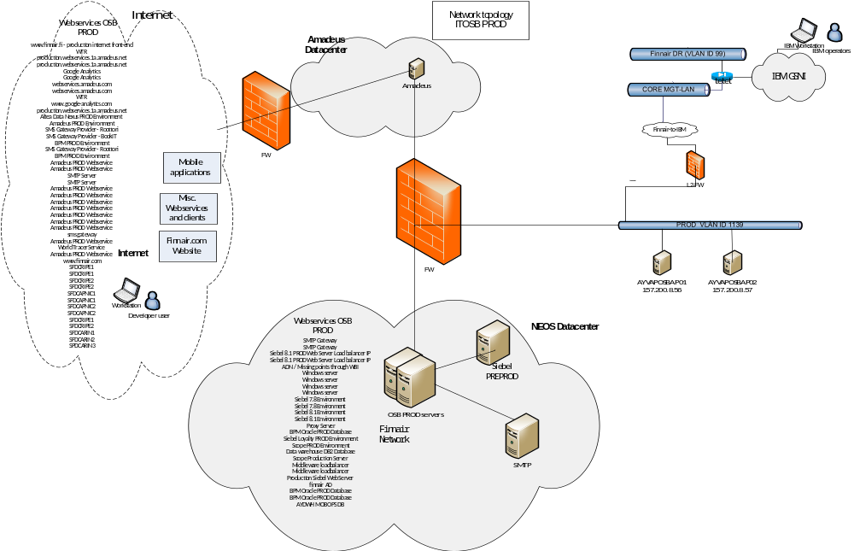

Target Network Connections
Table 5-20 Target Server IP addresses
Server Name | Platform Type | Env | Network Zone | Location | In IP | Out IP | Mgmt IP | RSA IP
AYVAPOSBAP01 | Virtual | Prod | Prod Data- VLAN 1139 | IBM DC | 157.200.8.56 | 157.200.8.56 | N/A | N/A
AYVAPOSBAP02 | Virtual | Prod | Prod Data- VLAN 1139 | IBM DC | 157.200.8.57 | 157.200.8.57 | N/A | N/A

Table 5-21 Target Network Connections
From | Network Zone | Out IP | To | Network Zone | In IP | Destination Port/App/Protocol
Admin PC | IBM GSNI | Dynamic | OSB Application server | PROD VLAN | 157.200.8.56  157.200.8.57 | 22 - SSH  7005, 7070, 7080 - HTTP  7043, 7053, - HTTPS  8005, 8070, 8080 - HTTP  8043, 8053- HTTPS
ITC Access | ITC Infotech Network | 192.168.96.0/24 | OSB application server | PROD VLAN 1139 | 157.200.8.57 | 22
ITC Access | ITC Infotech Network | 192.168.96.0/24, | OSB application server | PROD VLAN 1139 | 157.200.8.57  157.200.8.56 | 7005, 7070, 7080, 8005, 8070, 8080, 7043, 7053, 8043, 8053, 22
Access from Finnair Network | Finnair Internal Network | 157.200.0.0/16  194.197.255.0/24, 157.200.154.133/32 | OSB application server | PROD VLAN 1139 | 157.200.8.57  157.200.8.56 | 80, 443, 22, 7005, 7070, 7080, 8005, 8070, 8080, 7043, 7053, 8043, 8053
Logica Access | Logica Access | To be identified by Jason | OSB application server | PROD VLAN 1139 | 157.200.8.57  157.200.8.56 | 80, 443
Siebel 8.1 | Siebel 8.1 PROD App Server | 172.19.96.82 | OSB application server | PROD VLAN 1139 | 157.200.8.57 | 80
Informatica /NEOS | PROD INFORMATICA SERVER | 10.100.132.132 | OSB application server | PROD VLAN 1139 | 157.200.8.57 | 7005
Informatica /NEOS | PROD INFORMATICA SERVER | 10.100.132.132 | OSB application server | PROD VLAN 1139 | 157.200.8.56 | 8005
OSB application server | PROD VLAN 1139 | 157.200.8.57  157.200.8.56 | SMTP Gateway | FINNAIR PROD LAN (CGI) | 157.200.13.44 | 25
OSB application server | PROD VLAN 1139 | 157.200.8.57  157.200.8.56 | Siebel 8.1 PROD Web Server Load balancer IP | FINNAIR PROD LAN (NEOS) | 172.19.96.234 | 80
OSB application server | PROD VLAN 1139 | 157.200.8.57  157.200.8.56 | www.finnair.fi - production internet front-end | Internet | 194.145.50.111 | 80, 443
OSB application server | PROD VLAN 1139 | 157.200.8.57  157.200.8.56 | ADN / Missing points through WBI | FINNAIR PROD LAN (CGI) | 157.200.16.170 | 7080
OSB application server | PROD VLAN 1139 | 157.200.8.57  157.200.8.56 | WTR | Internet | 57.255.16.128 | 443
OSB application server | PROD VLAN 1139 | 157.200.8.57  157.200.8.56 | Windows server | FINNAIR PROD LAN (NEOS) | 172.19.96.78 | 22
OSB application server | PROD VLAN 1139 | 157.200.8.57  157.200.8.56 | Windows server | FINNAIR PROD LAN (NEOS) | 172.19.96.79 | 22
OSB application server | PROD VLAN 1139 | 157.200.8.57  157.200.8.56 | Siebel 7.8 Environment | FINNAIR PROD LAN (CGI) | 157.200.88.133 | 80
OSB application server | PROD VLAN 1139 | 157.200.8.57  157.200.8.56 | Siebel 8.1 Environment | FINNAIR PROD LAN (NEOS) | 172.19.96.234 | 80
OSB application server | PROD VLAN 1139 | 157.200.8.57  157.200.8.56 | production.webservices.1a.amadeus.net | Internet | 194.76.166.67 | 80
OSB application server | PROD VLAN 1139 | 157.200.8.57  157.200.8.56 | Google Analytics | Internet | 74.125.39.101, 74.125.39.102, 74.125.39.113, 74.125.39.138, 74.125.39.139, 74.125.39.100 | 80
OSB application server | PROD VLAN 1139 | 157.200.8.57  157.200.8.56 | webservices.amadeus.com | Internet | 82.150.229.134 | 443
OSB application server | PROD VLAN 1139 | 157.200.8.57  157.200.8.56 |  | FINNAIR PROD LAN (NEOS) | 172.19.98.10 | 80
OSB application server | PROD VLAN 1139 | 157.200.8.57  157.200.8.56 | WTR | Internet | 57.255.16.196 | 443
OSB application server | PROD VLAN 1139 | 157.200.8.57 157.200.8.56 | www.google-analytics.com | Internet | 209.85.146.100, 209.85.146.101, 209.85.146.102, 209.85.146.113, 209.85.146.138, 209.85.146.139 | 80
OSB application server | PROD VLAN 1139 | 157.200.8.57 , 157.200.8.56 | production.webservices.1a.amadeus.net | Internet | 194.76.166.67 | 80, 443
OSB application server | PROD VLAN 1139 | 157.200.8.57 /157.200.8.56 | Proxy Server | FINNAIR PROD LAN (NEOS) | 172.19.100.164 | 3128
OSB application server | PROD VLAN 1139 | 157.200.8.57  157.200.8.56 | BPM Oracle PROD Database | FINNAIR PROD LAN (CGI) | 157.200.16.144 | 1525
OSB application server | PROD VLAN 1139 | 157.200.8.57  157.200.8.56 | Altea Data Nexus PROD Environment | Internet | prod-ads.webservices.ay.amadeus.net:22006  194.76.166.93 | 22006,80
OSB application server | PROD VLAN 1139 | 157.200.8.57  157.200.8.56 | Amadeus PROD Environment | Internet | production.webservices.1a.amadeus.net  194.76.166.67 | 80
OSB application server | PROD VLAN 1139 | 157.200.8.57  157.200.8.56 | SMS Gateway Provider - Roottori | Internet | gw1.roottori.fi/eapi/push  87.108.54.100 | 80, 443
OSB application server | PROD VLAN 1139 | 157.200.8.57  157.200.8.56 | SMS Gateway Provider - BookIT | Internet | es20.bookit.net  193.185.151.59 | 8080, 443
OSB application server | PROD VLAN 1139 | 157.200.8.57  157.200.8.56 | Siebel Loyalty PROD Environment | FINNAIR PROD LAN (NEOS) | 172.19.96.234 | 80
OSB application server | PROD VLAN 1139 | 157.200.8.57  157.200.8.56 | BPM PROD Environment | Internet | 194.145.50.90 | 8080, 8070,  9090, 9080
OSB application server | PROD VLAN 1139 | 157.200.8.57  157.200.8.56 | Scope PROD Environment | FINNAIR PROD LAN (CGI) | was-applications.finnair.fi  157.200.15.200 | 80
OSB application server | PROD VLAN 1139 | 157.200.8.57  157.200.8.56 | Data warehouse DB2 Database | FINNAIR PROD LAN (CGI) | 157.200.16.188 | 50000
OSB application server | PROD VLAN 1139 | 157.200.8.57 157.200.8.56 | SMS Gateway Provider - Roottori | Internet | 62.61.85.34 | 80, 443
OSB application server | PROD VLAN 1139 | 157.200.8.57 157.200.8.56 | BPM PROD Environment | Internet | 157.200.18.18 | 8080,  8070,  9090,  9080
OSB application server | PROD VLAN 1139 | 157.200.8.57  157.200.8.56 |  | FINNAIR PROD LAN (CGI) | 157.200.88.134 | 80, 443
OSB application server | PROD VLAN 1139 | 157.200.8.57 , 157.200.8.56 | Scope Production Server | FINNAIR PROD LAN (CGI) | 157.200.75.35 | 80
OSB application server | PROD VLAN 1139 | 157.200.8.57 , 157.200.8.56 | Middleware loadbalancer | FINNAIR PROD LAN (NEOS) | 172.19.96.235 | 80, 443
OSB application server | PROD VLAN 1139 | 157.200.8.57 , 157.200.8.56 | Middleware loadbalancer | FINNAIR PROD LAN (NEOS) | 172.19.96.74 | 1415
OSB application server | PROD VLAN 1139 | 157.200.8.57 , 157.200.8.56 | Production Siebel Web Server | FINNAIR PROD LAN (NEOS) | 172.19.96.10 | 80, 9704
OSB application server | PROD VLAN 1139 | 157.200.8.57 , 157.200.8.56 | finnair AD | FINNAIR PROD LAN (CGI) | 157.200.75.41 | 389
OSB application server | PROD VLAN 1139 | 157.200.8.57  157.200.8.56 | Amadeus PROD Webservice | Internet | nodeA1.production.webservices.1a.amadeus.com/ 171.17.16.33 | 80/443
OSB application server | PROD VLAN 1139 | 157.200.8.57  157.200.8.56 | Amadeus PROD Webservice | Internet | nodeA1.production.webservices.1a.amadeus.com/ 171.17.16.33 | 80/443
OSB application server | PROD VLAN 1139 | 157.200.8.57  157.200.8.56 | SMTP Server | Internet | 157.200.93.25 | 25
OSB application server | PROD VLAN 1139 | 157.200.8.57  157.200.8.56 | Amadeus PROD Webservice | Internet | www.oneworld.com (66.96.130.69) | 80/443
OSB application server | PROD VLAN 1139 | 157.200.8.57  157.200.8.56 | Amadeus PROD Webservice | Internet | www.web-mn.com (23.23.175.3, 107.20.199.207) | 80/443
OSB application server | PROD VLAN 1139 | 157.200.8.57  157.200.8.56 | Amadeus PROD Webservice | Internet | go.urbanairship.com (184.31.89.14 ) | 80/443
OSB application server | PROD VLAN 1139 | 157.200.8.57  157.200.8.56 | BPM Oracle PROD Database | NA | 10.100.132.210 | 1521
OSB application server | PROD VLAN 1139 | 157.200.8.57 ,157.200.8.56 | sms gateway | Internet | 217.140.134.8 | 80
OSB application server | PROD VLAN 1139 | 157.200.8.57 ,157.200.8.56 | Amadeus PROD Webservice | Internet | sns.eu-west-1.amazonaws.com( 176.32.110.38)dynamic ip address | 443
OSB application server | PROD VLAN 1139 | 157.200.8.57 ,157.200.8.56 | AYDWH MOB OPS DB | NA | 10.100.160.30 10.100.160.31 10.100.160.40 10.100.160.41 10.100.160.42 | 1521
OSB application server | PROD VLAN 1139 | 157.200.8.57 ,157.200.8.56 | World Tracer Service | Internet | webservice.worldtracer.aero (57.250.192.197) | 443
OSB application server | PROD VLAN 1139 | 157.200.8.57 ,157.200.8.56 | Amadeus PROD Webservice | Internet | 82.150.229.130 | 443
OSB application server | PROD VLAN 1139 | 157.200.8.57 , 157.200.8.56 |  | FINNAIR PROD LAN (CGI) | 157.200.32.40 | 7300
OSB application server | PROD VLAN 1139 | 157.200.8.57 , 157.200.8.56 |  | FINNAIR PROD LAN (CGI) | 157.200.32.40 | 7301
OSB application server | PROD VLAN 1139 | 157.200.8.57 , 157.200.8.56 | www.finnair.com | Internet | 23.57.105.127 | 80/443
OSB application server | PROD VLAN 1139 | 157.200.8.57 ,157.200.8.56 |  | FINNAIR PROD LAN (CGI) | 157.200.40.0/22 | 80/443
OSB application server | PROD VLAN 1139 | 157.200.8.57 ,157.200.8.56 |  | FINNAIR PROD LAN (CGI) | 157.200.40.0/22 | 6379
OSB application server | PROD VLAN 1139 | 157.200.8.57 ,157.200.8.56 |  | FINNAIR PROD LAN (CGI) | 157.200.75.27 | 389
OSB application server | PROD VLAN 1139 | 157.200.8.57 ,157.200.8.56 |  | Internet | Auth.exacttargetapis.com | 80/443
OSB application server | PROD VLAN 1139 | 157.200.8.57 ,157.200.8.56 |  | Internet | Auth-test.exacttargetapis.com | 80/443
OSB application server | PROD VLAN 1139 | 157.200.8.57 ,157.200.8.56 |  | Internet | www.exacttargetapis.com | 80/443
OSB application server | PROD VLAN 1139 | 157.200.8.57 ,157.200.8.56 | SFDCRIPE1 | Internet | 85.222.128.0/19 | 80/443
OSB application server | PROD VLAN 1139 | 157.200.8.57 ,157.200.8.56 | SFDCRIPE1 | Internet | 85.222.128.0/19 | 1024–66535
OSB application server | PROD VLAN 1139 | 157.200.8.57 ,157.200.8.56 | SFDCRIPE2 | Internet | 185.79.140.0/22 | 80/443
OSB application server | PROD VLAN 1139 | 157.200.8.57 ,157.200.8.56 | SFDCRIPE2 | Internet | 185.79.140.0/22 | 1024–66535
OSB application server | PROD VLAN 1139 | 157.200.8.57 ,157.200.8.56 | SFDCAPNIC1 | Internet | 202.129.242.0/23 | 80/443
OSB application server | PROD VLAN 1139 | 157.200.8.57 ,157.200.8.56 | SFDCAPNIC1 | Internet | 202.129.242.0/23 | 1024–66535
OSB application server | PROD VLAN 1139 | 157.200.8.57 ,157.200.8.56 | SFDCAPNIC2 | Internet | 182.50.76.0/22 | 80/443
OSB application server | PROD VLAN 1139 | 157.200.8.57 ,157.200.8.56 | SFDCAPNIC2 | Internet | 182.50.76.0/22 | 1024–66535
OSB application server | PROD VLAN 1139 | 157.200.8.57 ,157.200.8.56 | SFDCRIPE1 | Internet | 85.222.128.0/19 | 80/443
OSB application server | PROD VLAN 1139 | 157.200.8.57 ,157.200.8.56 | SFDCRIPE2 | Internet | 185.79.140.0/22 | 80/443
OSB application server | PROD VLAN 1139 | 157.200.8.57 ,157.200.8.56 | SFDCARIN1 | Internet | 96.43.144.0/20 | 80/443
OSB application server | PROD VLAN 1139 | 157.200.8.57 ,157.200.8.56 | SFDCARIN2 | Internet | 136.146.0.0/15 | 80/443
OSB application server | PROD VLAN 1139 | 157.200.8.57 ,157.200.8.56 | SPDCARIN3 | Internet | 204.14.232.0/21 | 80/443
OSB application server | PROD VLAN 1139 | 157.200.8.57 ,157.200.8.56 | 10.100.132.197 | Neos | 10.100.132.197 | 1521
OSB application server | PROD VLAN 1139 | 157.200.8.57 ,157.200.8.56 | munaydwhpdbr05.finnair.fi | Neos | munaydwhpdbr05.finnair.fi | 1521
OSB application server | PROD VLAN 1139 | 157.200.8.57 ,157.200.8.56 | SCAN-MDPRAC.FINNAIR.FI | Neos | SCAN-MDPRAC.FINNAIR.FI | 1521
OSB application server | PROD VLAN 1139 | 157.200.8.57 ,157.200.8.56 | SCAN-DWPRAC.finnair.fi | Neos | SCAN-DWPRAC.finnair.fi | 1521
OSB application server | PROD VLAN 1139 | 157.200.8.57 ,157.200.8.56 | 10.100.132.198 | Neos | 10.100.132.198 | 1521

Target Systems Management Model
Target system will be placed in the standard Finnair network in the DC.

Availability
The system is available for 24/7. No scheduled service windows.

Backup & Recovery Management
If IBM DC: The TSM tool will be used for backup and recovery.

Table 5-22 TSM Backup List
Hostname | TSM Node Name | TSM Ver-sion | TSM Component Used (b-a, TDP for xxx) | TSM Schedules Used | TSM Client Option Set Used
AYVAPOSBAP01 | AYVAPOSBAP01 | N/A | n/a | DAYLY_INCR  at 21:00 | Standard
AYVAPOSBAP02 | AYVAPOSBAP02 | N/A | n/a | DAYLY_INCR  at 21:00 | Standard
Backup schedules; Daily Incremental; Weekly Full
Retention time: The weekly full backup must be stored for 3 years.

Operations Management
The Tivoli tool will be used for Monitoring.
Standard server monitoring is used, on disk, CPU, memory, i/o etc.
No special operational management on the application level

Batch Management
Only internal scheduled batch jobs.

Performance / Capacity Management
As per IBM standard.

Change Management
The ISM Maximo tool will be used for change management.

Configuration / Inventory Management
As per Quardian standard.

Security Management
As per ITCS400.

Disaster Recovery / Continuity Management
There is no specific disaster recovery plan for this application.
Restoring of a server is done using TSM backup

Problem Management
The ISM Maximo tool will be used for problem management.
The system administrator is acting as both help desk and problem owner/manager.
Problems recognized by users are registered in PM.
Problems that are not initiated by users (e.g. erroneous tape drive) are not registered in any tool.

Data Management
No change in data management.

Software Control & Distribution
Finnair is responsible for purchasing and managing all licenses.
Software is distributed / installed manually.

Service Level Management
The categories of service classes offered in the DC are as follows:
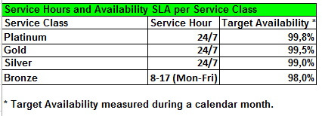
Service Level System configuration

Platinum Dual data center infrastructure, high availability configuration, built in redundancy for disks, network adapters, standby processor available to take workload and Highly Available software such as Microsoft Cluster Services or HACMP to automatically control fail over to standby. Data is replicated to
physically separate storage. Applications running on Platinum service levels must be able to support high-availability fail-over operations.

Gold high availability configuration, built in redundancy for disks, network adapters, standby processor available to take workload and highly available software such as Microsoft Cluster Services or HACMP or clustering provided by platform (e.g. VMWare Vmotion) to automatically control fail over to standby.

Data is replicated to physically separate storage. Applications running on Gold service levels must be able to support high-availability fail-over operations.

Silver Cold, Warm or Hot Standby configuration, no automated fail over software for Cold or Warm but Hot Standby may use for manual fail over + RAID / Mirror / Redundancy for disk environment.

Bronze Single system, mirrored system disk or RAID and recoverable backup

Iron Single system, mirrored system disk or RAID and recoverable backup

The target application will be placed in service class: Gold

Testing and Validation
IBM will perform systems test, i.e. verifying that application ready server(s) has been installed with the requested OS and storage, standard middleware (monitoring, backup, etc.), and firewalls has been opened.
Finnair will perform technical tests and user application tests.

System Acceptance
Reference to section 4.2.

Deployment
Deployment and go-live according to Cutover plan, see section 6.1.

Documentation
Documentation per application for the below tasks is stored in the Finnair Europe Team room
# | Task
1 | Choose Servers for Server Migration – the Wave
2 | Checkpoint: Staff for Wave and access rights in place incl. 3rd party
3 | Establish information about Server AS IS environment incl. Applications and interfaces
4 | Customer sign off concerning Server SLA level, physical / virtual server(s) in target
5 | Check Readiness of Target environment for XXX of Servers (VMware, SAN, NW, Licenses)
6 | Check availability of physical Servers in target as needed and agreed
7 | Fill in Order Form for Server Factory to build Application Ready Servers in Target
8 | Install DB / MW on target servers as needed
9 | Install Applications on new servers in Target environment
10 | Agree on method of Data Migration and initiate the process
11 | Perform an initial full backup of Finnair files per Server Image
12 | Perform a restore test of files initially backed up per Server Image.
13 | Provide Test Cases and Test Plan
14 | Provide DID (Detailed Implementation Document) for transformation of Servers
15 | Provide Cutover Plan
16 | Provide Change Request and agree (Finnair / IBM) on date / time for transformation
17 | Provide Operator Instructions for Servers in target environment.
18 | Perform Kick Off meeting with participants in Cutover Change
19 | Perform initial User Acceptance Test
20 | Complete delta Data Migration
21 | Perform Cutover during Change Window / Change DNS / Management of interfaces
22 | Perform final User Acceptance Test
23 | GO LIVE / NO GO Decision
24 | Inform Helpdesk that servers are in production in Target
25 | Perform Handover Process to BAU Steady State Incl. Activation of Monitoring
26 | Check Compliance Status
27 | Check that Service Management disciplines are implemented according to Schedule 8
28 | Agree on Decommission of Source Servers
29 | Checkpoint: Wave Documentation in place

Transformation guidelines
Rules for relocating applications to SL DC and IBM DC
- All applicable servers must be moved to SL DC
- All applicable physical servers must be virtualized
- One to one cloning is preferred relocation method
- If server can’t be cloned it will be re-installed on IBM side.
- Relocating to IBM DC needs documented justification

Service Move
The primary communication deliverable is the Cutover Plan.

Cutover Plan
The Cutover Plan is a plan that details exactly what tasks must be done in the various functional areas of an IT organization to provide for a successful relocation of one or more components of the IT infrastructure. The plan is a living document that is updated and carried out throughout the life of the project. The Cutover Plan is owned by the PM and will be finalized after this DID is approved. It can be requested from the Project Manager.

Architectural input
Below is a generic cutover plan. The activities necessary from an architectural point of view is marked with “X” in the column “Mark”.
PREREQUISITES
Activity | Mark | Responsible | Comments
Finnair resources identified | X | IBM (PM)  Finnair
Check/Request access for Customer and Project Resources to Cloud T&T Community/Connections | X | IBM (PM) | Wave plan week 2
Business test cases and Test Plan developed | X | Finnair | Wave plan week 2
Check current system health by following identified test cases/test scenarios | X | Finnair
DID developed and approved by the Customer | X | IBM (Architect) | PM will ensure Finnair’s approval  Wave plan week 3
Send change request to (CGI / Neos / Norra) for cloning | X | IBM (PM)
Service Window planning and receive approval | X | IBM (PM)  Finnair | AYVAT
Schedule a cutover plan meeting with stake holders to walkthrough the DRAFT plan and agree the roles and responsibilities | X | IBM (PM)
Schedule an online meeting for all stakeholders to collaborate and communicate their tasks on the cutover date and time. | X | IBM (PM)
Schedule a walkthrough final cutover plan meeting with all the cutover participants and get their commitment | X | IBM (PM)  Finnair | CGI and NEOS persons should also be invited.
Systems access in source environment in place incl. 3rd party | X | Finnair (CGI / Neos / Norra) | Wave plan week 3
Systems access in target environment in place incl. 3rd party | X | IBM (SME)  Finnair (CGI / Neos / Norra) | Wave plan week 3
Firewall openings for the early UAT has been identified | X | IBM (Architect)
Firewalls requested opened | X | IBM (PM)
Verify that firewalls are opened to perform the early UAT. | X | IBM (Wintel/Linux/AIX SME) | Wave plan week 4
Early UAT performed | X | Finnair | Wave plan week 4
Staff for transformation in place including backup resources for Service Window | X | IBM (PM)
Information about application and dependencies in place | X | Finnair
Checked that eventual license issues are solved | X | IBM (PM)  Finnair
Change Request for Cutover described | X | IBM (PM)
Citrix installed in target |  | IBM (IMI)
Data transfer from source to target for test purposes (SQL DB) |  | IBM (DBA)
Application installed / customized in target | X | IBM (SME) | Windows/Linux/AIX SME
System test | X | IBM (SME)
Pre-test of application performed in target | X | Finnair
FW openings checked and in place | X | IBM (SME) | Windows/Linux/AIX SME verifies connections in place
Operator Instruction developed | X | IBM (SME) | Windows/Linux/AIX SME  (with input from Sub-system/Service Owners)
Production Support handover process/meeting (PreBAU / BAU) | X | IBM (PM) | https://w3-connections.ibm.com/wikis/home?lang=en-us#!/wiki/I-OPM-DK-01%20Wiki/page/PS%20-%20Frontpage
Make sure that dependent Services on other Servers are ready | X | IBM (PM) | Database, File-shares, external servers, and the like
Approved Change Request in place | X | IBM (PM)
New application interlock for End Users is communicated in Local Language |  | Finnair
Kick Off meeting with participants in Cutover 3rd work day before Change. | X | IBM (PM)
Inform Finnair SDM about planned transformation | X | IBM (PM)
Provide final information to End Users about down time of application by <date> from <time> to <time>  (End User communication about Service Window/Maintenance) | X | Finnair

Activity on go live day
Activity | Mark | Responsible | Comments
Process Control via Online Meeting/Conference |  | IBM (PM)
All participants join the Conference 30 minutes before Service Window opens | X | All cutover participants
Broadcast/Communicate to End Users that the informed Application/Service maintenance break/window will begin now | X | Finnair
Close down database in current environment |  | Finnair (CGI / Neos / Norra)
Copy data to NAS storage | X | Finnair (CGI) | Only relevant for relocation from CGI
Copy data from vendor to IBM DC | X | IBM (SME)
Startup application and database in target environment | X | IBM (SME) | Windows/Linux/AIX SME and DBA
Verify availability of applications in Citrix |  | IBM (IMI)
Perform technical test of interfaces towards external 3’th party servers | X | IBM (SME)
Perform Acceptance Test for application according to test plan and test cases (UAT) | X | Finnair
Add Users to application Security Group | X | IBM (SME)
If moved via Cloning, after first Acceptance Test, add/install IBM Tools/processes  (Agents: Antivirus, Backup, Monitoring & Alert Test, SW/License scanner, Endpoint Management, Automation) |  | IBM (SME)
If Agents added after first Acceptance Test, preform Second Test Round |  | IBM (SME) &  Finnair
GO LIVE / NO GO Decision for the application | X | Finnair
Inform Dublin service desk about GO decision | X | IBM (PM)
Inform CGI / Neos / Norra service desk about GO decision | X | IBM (PM) | CGI / Neos / Norra Service Desk must call Dublin Service Desk.
Announcement of decision incl. DPE | X | Finnair
Go Live Procedures  (Asset Management/Registrations, Monitoring, Schedule Backup, | X | IBM (SME)

Fall back activity
Activity | Mark | Responsible | Comments
Close down application in current environment | X | IBM (SME)
Sync/copy data back | X | IBM (SME)  Finnair (CGI / Neos / Norra)
Startup application and database in vendor’s environment | X | Finnair (CGI / Neos / Norra)

QUALIFICATION PROCESS
Activity | Mark | Responsible | Comments
Monitor system for one week to see if any issues have been identified. | X | IBM(SIL) | Incident mgmt process are to be used.
If there are any problems to the application then report the issues through incident mgmt process/tool | X | Finnair

Cleanup activity
Activity | Mark | Responsible | Comments
Decommission old Servers | X | CGI  Finnair
Closed Firewalls for Temporally/Un-Used IP’s | X | IBM (PM)  Finnair

Move Day Timeline
The Complex Relocation Move Day Timeline is a task-by-task description of how a specific move (server, mainframe storage, etc.) should occur under ideal conditions. The timeline is limited to the actual move day(s) and takes into account the necessary move strategy for the particular function; it incorporates times, roles, and dependencies for the actual move day. Contained within this plan are a series of decision points that determine if it is safe to continue with the move or if the environment should be restored to its original condition.
The detailed timeline is part of the Cutover Plan.

Communication plan
The communication plan is part of the cutover plan.

Rollback plan
The Rollback plan is part of the cutover plan.

Risk Assessment
The following risks have been identified.
# | Risk | Risk Description | Prob. | Impact on |  |  | Strategy
 |  |  |  | Cost | Sched. | Quality | Strategy
1 | Relocation fails | Relocation fails and cause cannot be determined within a reasonable time | LOW | LOW | MED | LOW | Roll back. A thorough function test mitigates this risk
2 | Errors caused by the migration from AIX 5.3 to AIX 7.1 will not be identified before the relocation |  | LOW | LOW | MED | MED | Troubleshoot and correct any issues.
3 | One or more of the connections will fail during the relocation | Many port openings to and from OSB server has been done, some could be failing after setup of new servers | LOW | LOW | MED | HIGH | Troubleshoot and correct any issues.
End of Document

